Brdo pri Lukovici, 29. July 2026

REPORT FROM SLOVENIA: IN ACCORDANCE WITH THE NEW DIRECTIVE, ONLY 1.79% OF HONEY BLENDS IN SLOVENIAN STORES ARE LABELED – GO TO A LOCAL BEEKEEPER!
A month and a half ago, on June 14, 2026, the Rules on the Quality and Labeling of Honey came into force. The key change incorporates Directive (EU) 2024/1438, which requires more precise origin labeling for honey blends. Instead of the old, vague label "blend of EU and non-EU honey," packers must now state all countries of origin alongside their corresponding percentages in descending order in the product's primary field of vision.
Because the Directive includes a safeguard mechanism allowing packers to sell off stocks placed on the market or labeled under the old rules (before June 14, 2026), the situation across Slovenia's six largest retailers remains virtually unchanged. Out of 56 honey blend products counted on store shelves, only one product was labeled in accordance with the new rules—found in a Hofer d.o.o. store. Four products were incompletely labeled, displaying only some countries of origin without their respective percentages. The remaining 51 products still carried the general label "blend of EU honey" or "blend of EU and non-EU honey."
This review confirms that packers intend to fully utilize the transitional period. Even though Directive (EU) 2024/1438 was adopted way back in May 14, 2024, consumers still rarely encounter the new labels on store shelves more than two years later.
Nevertheless, options do exist in Slovenia: alongside the 56 honey blends from various countries, 36 products of Slovenian origin were also observed. Furthermore, consumers can always purchase bee products directly from local Slovenian beekeepers. To find local suppliers, consumers can also use the Map of Active Producers of Slovenian Honey with Protected Geographical Indication (Slovenski med z zaščiteno geografsko označbo), accessible here: https://www.okusi-med.eu/zemljevid-smgo
Slovenian Beekeeper's Association and the European Beekeeping Association urge other countries to also actively inspect the current situation on the market. It is absolutely key for the consumer to know where honey comes from!

Boštjan Noč, President of the European Beekeeping Association and the Slovenian Beekeeper's Association
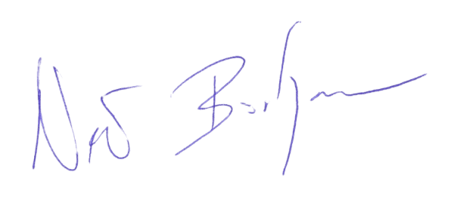

GENERAL SPONSOR OF THE EBA
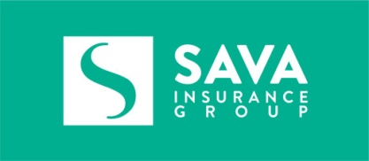

SILVER SPONSOR OF THE EBA
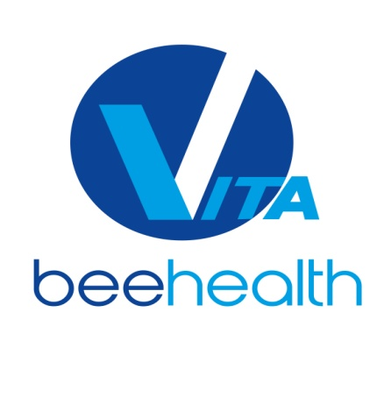
BRONZE SPONSOR OF THE EBA
