Brdo pri Lukovici, 28. July 2026

EBA Stands with French Beekeepers as Pesticide Rollback Sparks Outrage

The French parliament has reauthorised the exceptional use of nationally banned neonicotinoid pesticides—including acetamiprid and flupyradifurone—triggering deep anger across the beekeeping community.
Environmentalists and French beekeeping unions (UNAF) have condemned the decision as a catastrophic setback for biodiversity and pollinators. Scientific research shows that acetamiprid inflicts neurotoxic damage on honeybees, disrupting their memory, foraging capacity, and colony survival.
The European Beekeeping Association (EBA) stands fully in solidarity with our French colleagues. Reauthorising bee-toxic chemicals under the guise of agricultural emergencies threatens the future of European apiculture and undermines years of progress in pollinator protection. Bees are fundamental to biodiversity and our food systems; protecting them must remain a non-negotiable priority.
This decision underscores the urgent need for systemic change across Europe. Read the official EBA Position Paper on the Acetamiprid Vote to learn more about our stance against raising pesticide residue limits (voted for by the EU Parliament in December 2025) and how we are fighting to safeguard honeybees, the environment and the consumer.
Article: ‘Scandalous, irrational and irresponsible’: French beekeepers’ fury at lifting of pesticides ban | France | The Guardian
EBA position paper: https://ebaeurope.eu/acetamiprid-again/

Boštjan Noč, President of the European Beekeeping Association
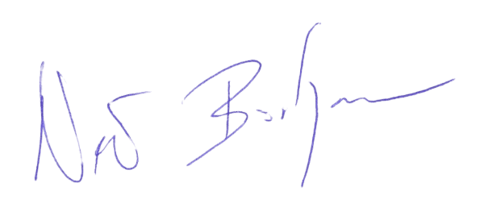

GENERAL SPONSOR OF THE EBA
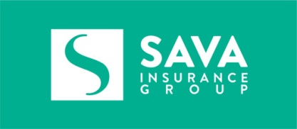

SILVER SPONSOR OF THE EBA

BRONZE SPONSOR OF THE EBA


