Brdo pri Lukovici, November 21. 2025.

Subject: Concerns of the Scientific Commission of the European Beekeeping Association Regarding the Recent Proposal on Pesticide Approvals

Dear Members of the European Commission,
Dear EU Commissioner for Agriculture and Rural Development, Mr Christophe Hansen,
Dear President of the European Parliament, Ms Roberta Metsola,
Dear EU Commissioner for Environment, Water Resilience and a Competitive Circular Economy, Ms Jessika Roswall,
Dear Chair of the Agri Committee, Ms Veronika VRECIONOVÁ,
Dear EU Members of Parliament,
Dear Copa-Cogeca,

On behalf of the Scientific Commission of the European Beekeeping Association, we wish to express our profound concern regarding the Commission’s recent proposal on pesticide approval procedures, as presented in the communication referenced in the PAN Europe report.
The proposal, as currently formulated, appears to prioritise the interests of the pesticide industry at the expense of the One Health paradigm, which encompasses the health of the environment, pollinators, animals, and the public. This approach is incompatible with the EU’s stated commitments to biodiversity protection, environmental stewardship, and sustainable agriculture.
We are particularly concerned that the proposal seems designed to neutralise the effects of the April 2024 ruling of the Court of Justice of the European Union, which reaffirmed the obligation of Member States to consider the most up-to-date scientific evidence when authorising the use of pesticides. Weakening these requirements would represent a serious setback for science-based policymaking and would undermine public trust in regulatory processes.
Furthermore, the provision allowing hazardous pesticides to remain on the market for up to three additional years after a ban has been imposed raises significant risks. Substances recognised as harmful — including endocrine disruptors, carcinogens, and neurotoxic compounds — could continue to be sold and applied long after their dangers have been formally acknowledged. Such delays are unacceptable given their potential impacts on pollinator health, ecosystem stability, food safety, and human well-being.
This proposal, if adopted, would reverse decades of progress in environmental and public health protections. It would weaken the foundations of scientific assessment in favour of short-term economic interests, with long-term consequences for society and the environment.
We strongly urge the Commission to reconsider this proposal and to reaffirm the central role of independent, current scientific evidence in all decisions related to pesticide regulation. Protecting pollinators and safeguarding ecosystems must remain a priority for the European Union, not only for beekeepers but for the resilience of agriculture and the health of present and future generations.
We remain at your disposal for scientific consultation and constructive dialogue.
Respectfully,

President Boštjan Noc – President of European Beekeeping Association
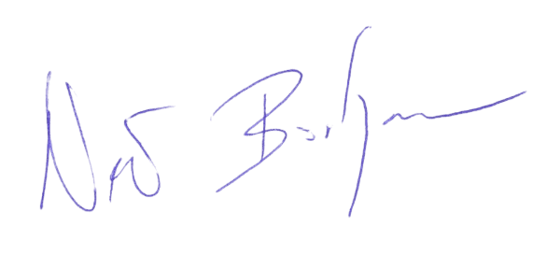

Prof. Dr. Aslı Özkırım – President of EBA Bee Health Scientific Commission
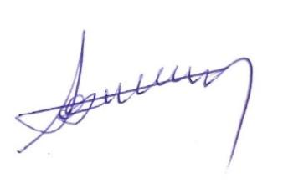

Dr. Giovanni Formato – Vice-President of EBA Bee Health Scientific Commission
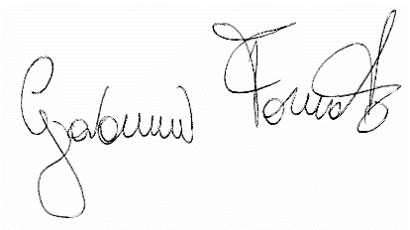

GENERAL SPONSOR OF THE EBA

SILVER SPONSOR OF THE EBA

SILVER SPONSOR OF THE EBA

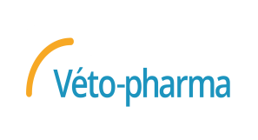
BRONZE SPONSOR OF THE EBA



