Brdo pri Lukovici, Slovenia, November 3, 2025.

Dear EU Commissioner for Agriculture and Rural Development, Mr Christophe Hansen,

Dear President of the European Parliament, Ms Roberta Metsola,

Dear Chair of the Agri Committee, Ms Veronika VRECIONOVÁ,

Dear EU Members of Parliament,

Subject: European Beekeeping Association strongly against the abolition of the beekeeping envelope

According to our information, it is being considered that, within the framework of the new CAP for the new programming period, the special beekeeping envelope will be abolished and the funds will be merged with other funds for agriculture.

The European Beekeeping Association, which includes 419,000 beekeepers from 30 countries, is asking you to maintain the special beekeeping envelope also in the new programming period of the EU's Common Agricultural Policy 2028-2034.

Without bees, there is no pollination, and unfortunately, without beekeepers, there will be no bees. Every third spoonful of food depends on bee pollination, which cannot be imported.

The beekeeping sector is in an extremely difficult situation, as according to the EU Commission, almost half of the honey is counterfeit. Unfortunately, there is no

solution in sight and beekeeping across Europe is threatened with collapse. Due to the huge unfair competition represented by counterfeit honey, beekeepers are already abandoning beekeeping and will do so even more in the future, as they will simply be forced to do so due to economic unsustainability.

Thinking about abolishing the special beekeeping envelope in these difficult times is unacceptable for beekeepers, moreover, we European beekeepers expect the beekeeping envelope to be preserved and that the funds for the preservation of bees and beekeeping to increase. We also expect dedicated funds from environmental funds as compensation for the pollinating service of bees. Support must be urgently strengthened, primarily through the immediate removal of counterfeit honey from the market.

Dear authorities in this field, we believe in you, and above all we believe that you are aware that without bees there is no food and without beekeepers there are no bees! Without bees there is no biodiversity, no green and blooming Europe ... ultimately there are no people.

Thank you in advance for your support of our proposal and we look forward to our cooperation in the future.

President of the European Beekeeping Association
Boštjan Noč
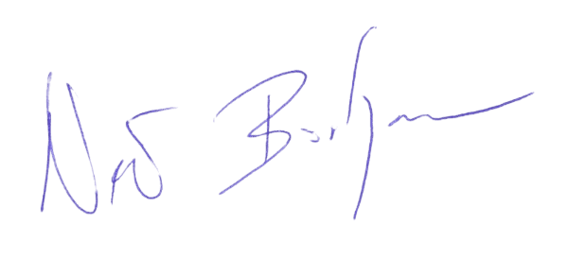

GENERAL SPONSOR OF THE EBA

SILVER SPONSOR OF THE EBA

SILVER SPONSOR OF THE EBA


BRONZE SPONSOR OF THE EBA



