Brdo pri Lukovici 8, Slovenia.
05.08.2025.

EBA Raises Concerns Over Increasing Honey Imports
The European Beekeeping Association (EBA) has recently addressed a letter to the European Commission which identified several legislative gaps that facilitate honey adulteration (the letter and the Position Paper are in attachment). Our main concerns are about insufficient border controls, lack of traceability and the absence of harmonised EU-wide methods for verifying honey authenticity. The EBA stressed that without rigorous checks and standardised testing, the integrity of the European honey market is at risk.
In this context, the EBA was informed of the recent decision by the European Commission to increase the duty-free honey import quota from Ukraine, raising it from 6,000 to 35,000 tonnes.
The EU and Ukraine are currently reviewing the Deep and Comprehensive Free Trade Area (DCFTA), as the previous agreement expired on 5 June 2025. Although the EBA appreciates the EU’s support for Ukraine in these challenging times, any new deal must also safeguard the interests of EU farmers—particularly those in sensitive sectors like beekeeping. Despite reassurances from the European Commission, the substantial increase in duty-free honey imports is one of the most significant changes under consideration in the updated agreement and raises serious concerns.
Right now, the EU honey market is under pressure on multiple fronts. Beekeepers are already struggling with the effects of climate change, rising production costs, and threats from invasive species. On top of this, they’re facing growing competition from low-priced imported honey—often of low quality and unclear origin—which has flooded the European market in recent years.
The situation is made worse by a lack of effective control over these imports. Fraudulent honey has become a defining issue in the sector. The recently launched “Honey Platform” working group at the European Commission is a welcome step. Its goals—to improve traceability and standardise authenticity checks—are necessary and urgent. But we’re not there yet. As things stand, it's extremely difficult to verify the true origin of imported honey. There are no harmonised methods across the EU for testing authenticity, and without that, it’s impossible to ensure consistent, reliable results. Until these gaps are properly addressed, any major increase in honey imports from any third country risks making a bad situation worse not only for the beekeepers but also for the consumers.
We urge decision-makers to hold off on expanding the quotas until robust systems are in place. Increasing imports before fixing the system put honest beekeepers at an even greater disadvantage and undermine efforts to restore trust in the European honey market.

Boštjan Noč
President of the European Beekeeping Association
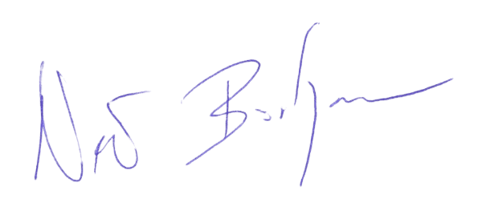

GENERAL SPONSOR OF THE EBA
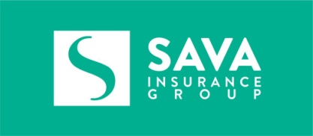
SILVER SPONSOR OF THE EBA
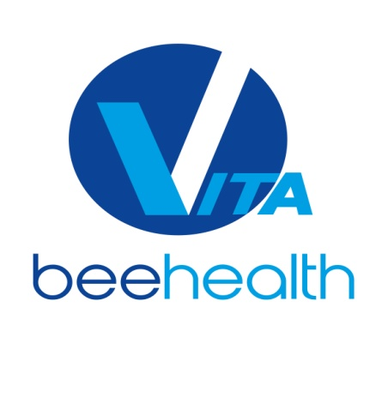
SILVER SPONSOR OF THE EBA

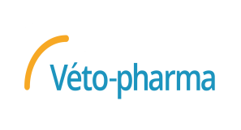
BRONZE SPONSOR OF THE EBA


BRONZE SPONSOR OF THE EBA

